- Interstellar Ascension 52inx38in $15,000
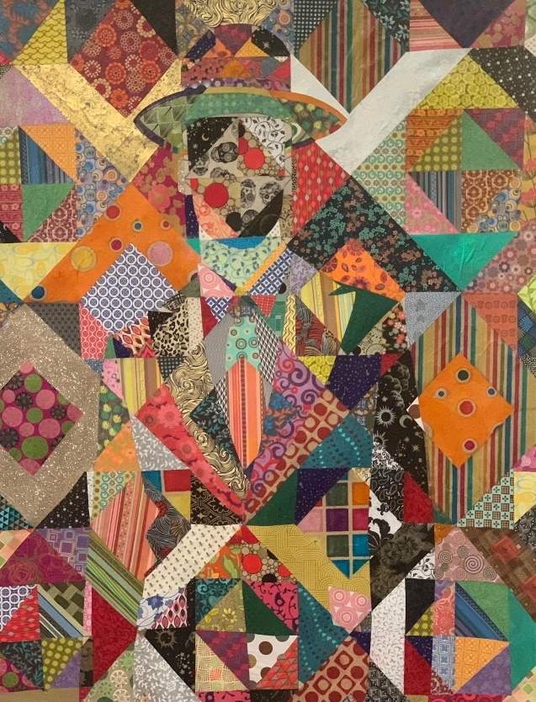
- Revivification 38inx36in $6800
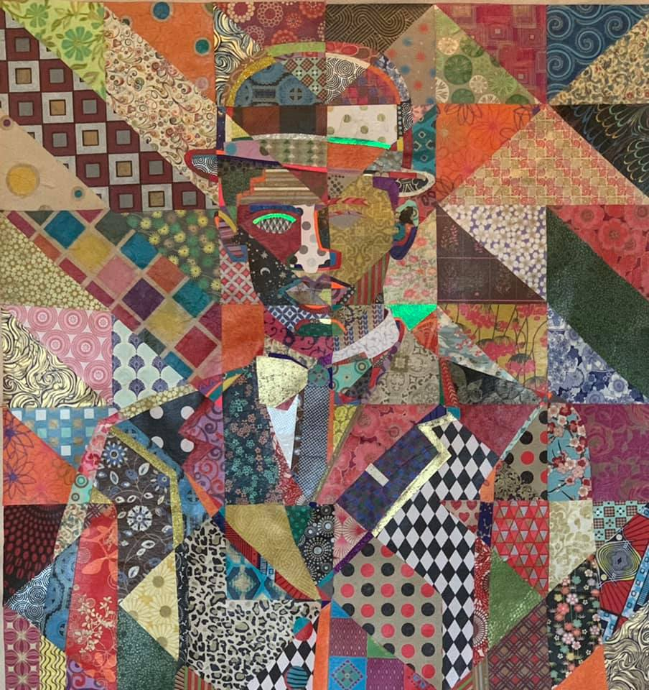

- Lady Celastrina 40inx34in $6500

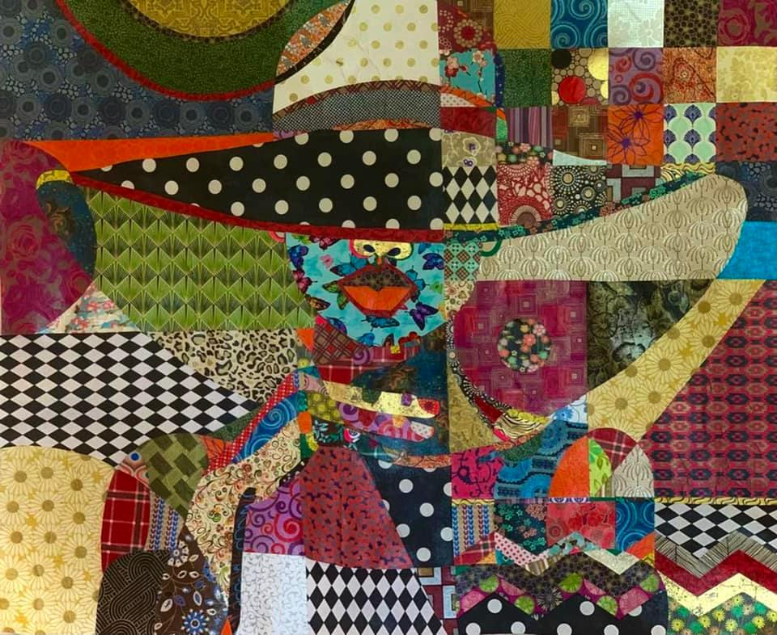

- Divine Intervention 50inx42in $10500
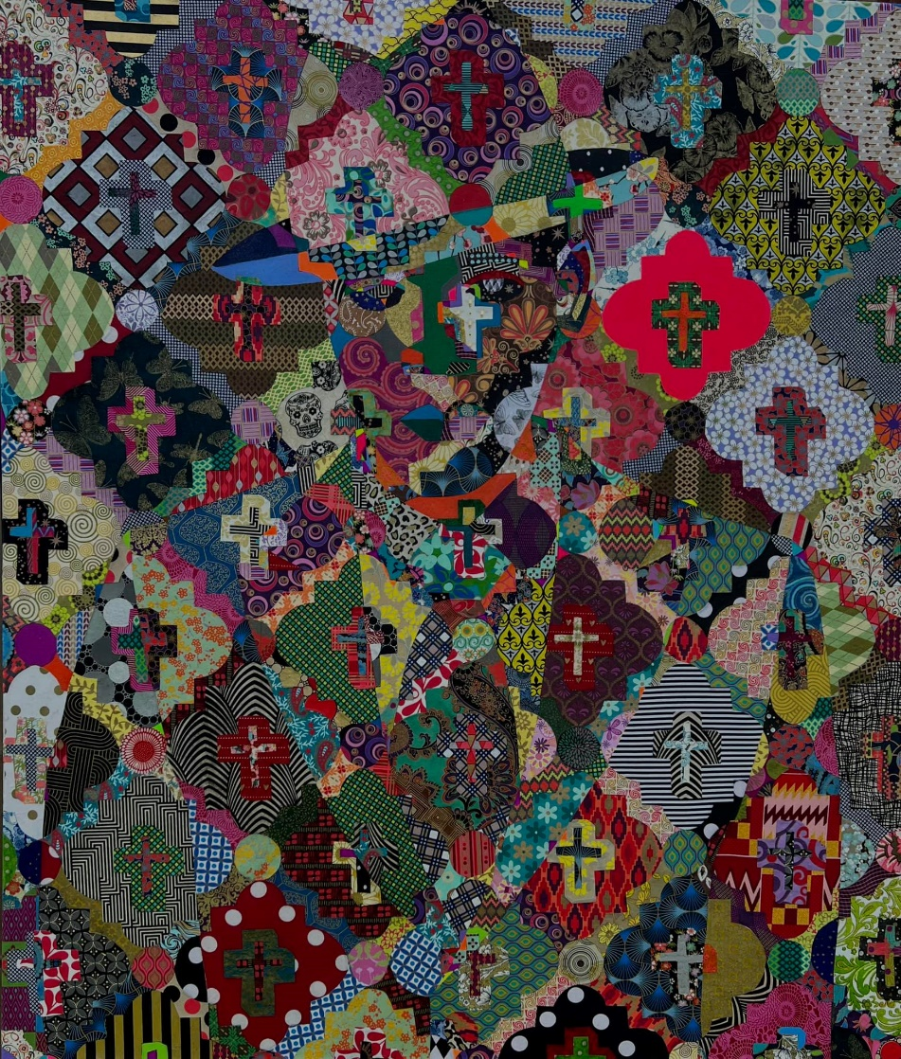

- First Lady Ethereal 40inx50in $10,000
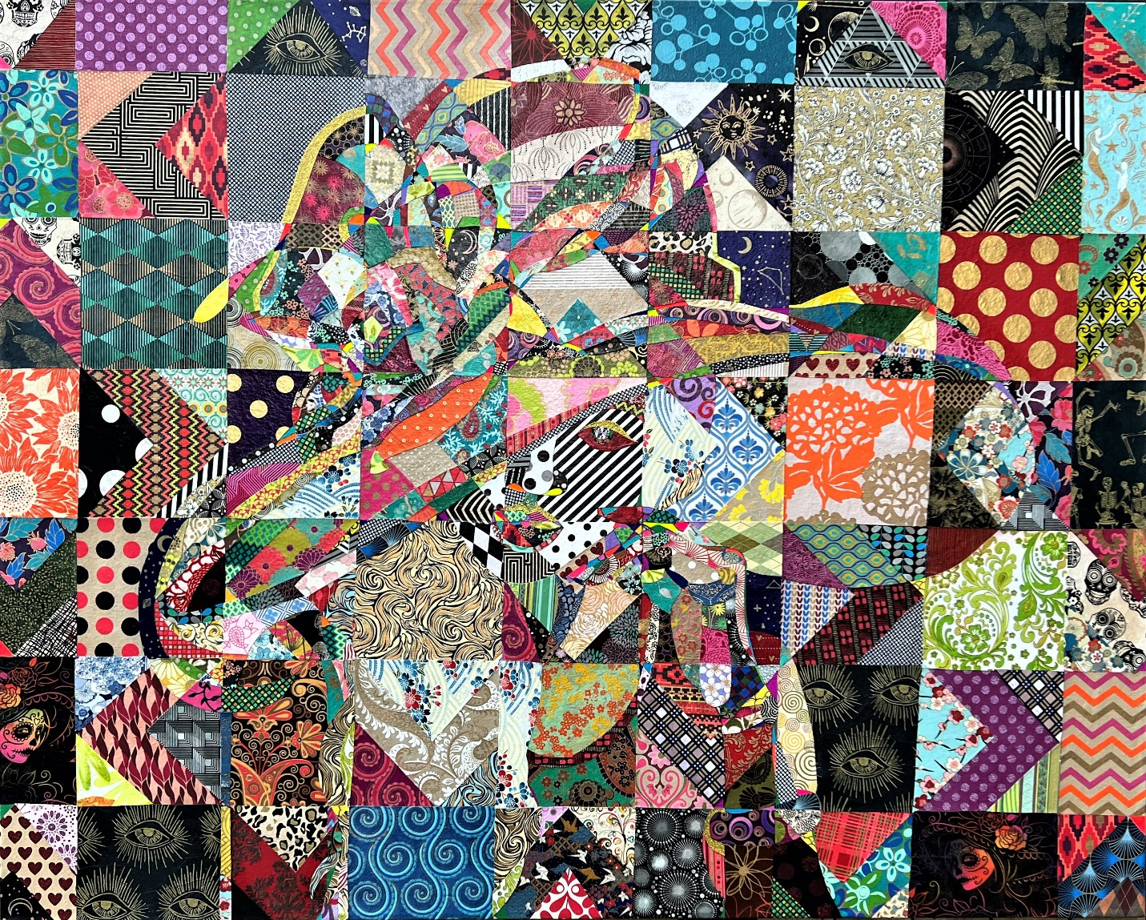

- Khonsu Eklips 36inx28in $5100

- Cosmically Sophisticated 38inx52in $9500
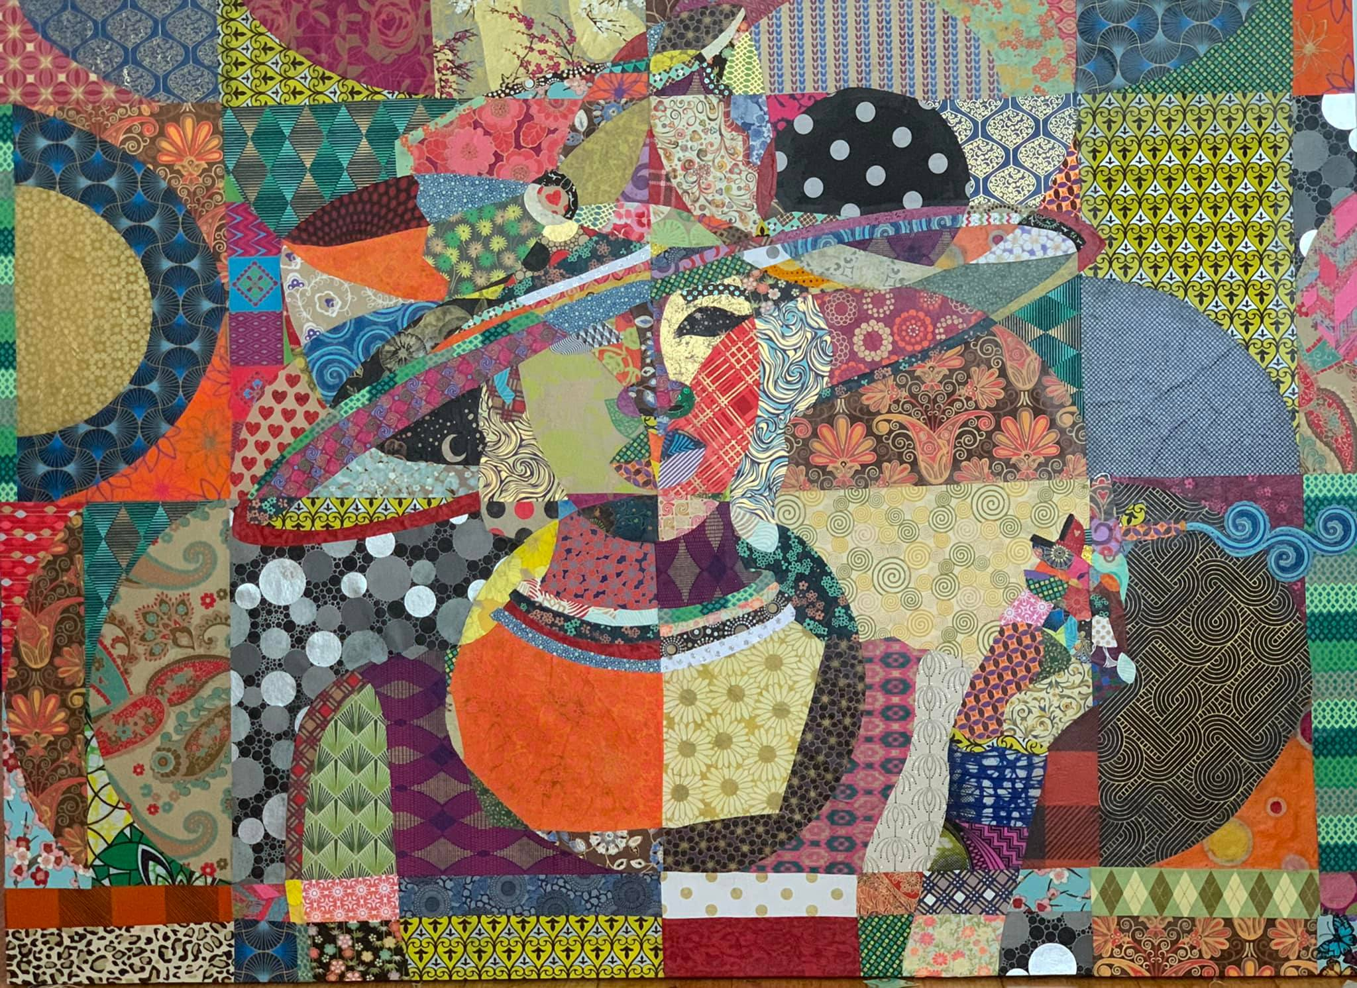
- Lady Celestial 42inx28in $5500
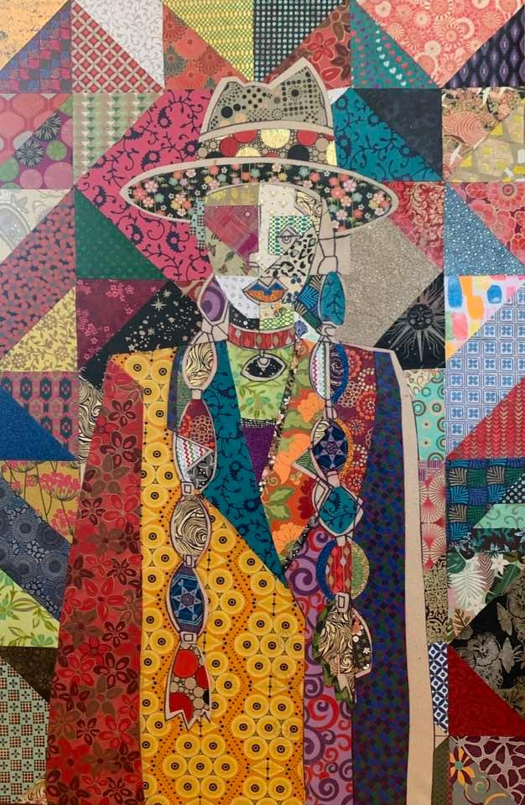

- Upon the Empyreal Throne 50inx44in $10,000
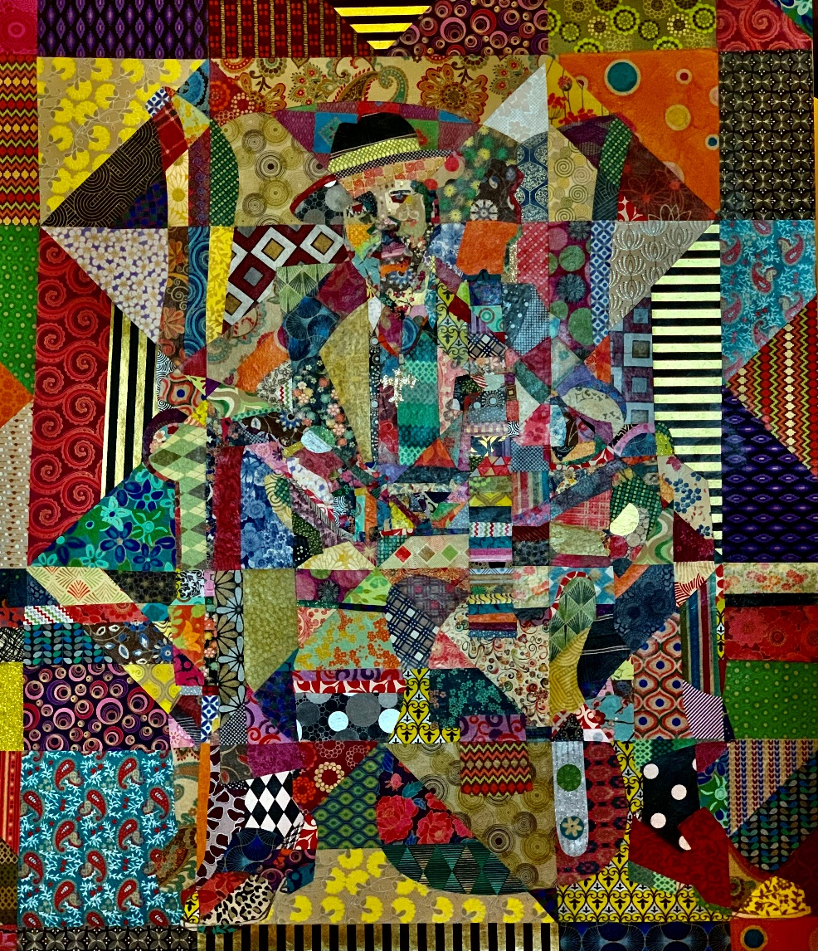
- Hevioso –The Rain man 58inx48in $13000
